Current State Overview

Current State Overview 1
Organizational Structure 3
Overview 3
1. Senior Management 3
Key Executives 3
Primary Responsibilities 3
2. Investment Committee 3
Committee Members 4
Primary Responsibilities 4
3. Investment Management 4
1. Investment Sourcing & Underwriting 4
Leadership 4
Team Structure 4
2. Asset Management 4
Leadership 4
Team Composition 4
3. Business Management 5
1. Finance & Accounting 5
2. Investment Operations & Reporting 5
3. Investor Relations 5
4. Firm Operations 5
Key Systems and Tools – TO BE ADDED 5
Existing Data Infrastructure – TO BE ADDED 5
Interdepartmental Dependencies 5
Reporting Dependencies 5
Overview 5
Reporting Workflow and Data Dependencies 6
Key Reports and Their Dependencies 6

Organizational Structure

Overview
Metropolitan’s organizational structure is designed for strategic leadership, investment execution, and operational efficiency. The firm operates through four primary divisions:
- Senior Management – Provides overall governance, risk oversight, and firm-wide leadership.
- Investment Committee – Exercises final investment decision-making authority.
- Investment Management – Responsible for deal sourcing, underwriting, and asset management.
- Business Management – Oversees finance, investor relations, legal, and operations.
With 31 professionals as of December 2024, Metropolitan maintains a highly specialized and disciplined team, ensuring robust investment strategy execution.

Senior Management
The Senior Management team is responsible for corporate governance, compliance, and strategic oversight.

Key Executives
- Paul Lisiak – Managing Partner, Chief Investment Officer (CIO) | 26 years of experience | University of Pennsylvania
- Julian Weldon – General Counsel, Chief Compliance Officer (CCO) | 27+ years of experience | University of East Anglia
- Stephen Faughnan – Managing Director | 26+ years of experience | Pace University, NYU Stern

Primary Responsibilities
- Investment Strategy & Execution
- Legal & Compliance Oversight
- Firm-wide Governance & Risk Management
Senior Management provides firm-wide leadership while ensuring regulatory compliance and risk mitigation.

Investment Committee
The Investment Committee (IC) is responsible for final investment approvals, portfolio oversight, and risk assessment.

Committee Members
- Paul Lisiak – Managing Partner, CIO
- Adrian Blumfield – IC Member | 30+ years of experience | University of Cambridge, London Business School
- Fred Ganning – IC Member | 30+ years of experience | Seton Hall University

Primary Responsibilities
- Final Investment Decision-Making
- Risk & Portfolio Management
- Fund Strategy & Capital Allocation
The IC ensures disciplined investment selection, risk mitigation, and adherence to the firm’s strategic objectives.

Investment Management
The Investment Management team is responsible for deal origination, underwriting, and active asset management.

Investment Sourcing & Underwriting
Handles deal origination, due diligence, and underwriting.

Leadership
- George Alifragis – Head of Operating Expert Network
- Richard Lin – Managing Director

Team Structure
- Vice Presidents & Principals – Lead investment sourcing and execution.
- Associates & Analysts – Support financial modeling, due diligence, and execution.
- 500+ Operating Expert Network – Provides specialized industry insights.

Asset Management
Responsible for post-investment oversight, loan servicing, and portfolio monitoring.

Leadership
- Alex Verba – Managing Director

Team Composition
- Vice Presidents & Associates – Oversee borrower relationships, financial monitoring, and performance optimization.
Total Investment Management Team: 14 Professionals

Business Management
The Business Management division oversees finance, investor relations, operations, and legal compliance.

Finance & Accounting
Responsible for financial reporting, fund accounting, and audit coordination.
- Douglas Gold – Chief Accounting Officer & Senior Vice President
- Team: Vice Presidents, Controllers, Fund Accountants.

Investment Operations & Reporting
Manages data analytics, investment performance reporting, and internal controls.
- Jason Bircann – Vice President
- Team: Senior Operations Associates & Analysts.

Investor Relations
Handles LP communications, fundraising support, and investor reporting.
- Scarly Almonte – Senior Associate

Firm Operations
Ensures legal compliance, administrative efficiency, and corporate governance.
- Kevin O’Block & Megan Krishnamurthy – Vice Presidents, Office of the CIO
- Benjamin Bertan – Associate General Counsel
Total Business Management Team: 14 Professionals

Key Systems and Tools – TO BE ADDED

Existing Data Infrastructure – TO BE ADDED

Interdepartmental Dependencies

Reporting Dependencies

Overview

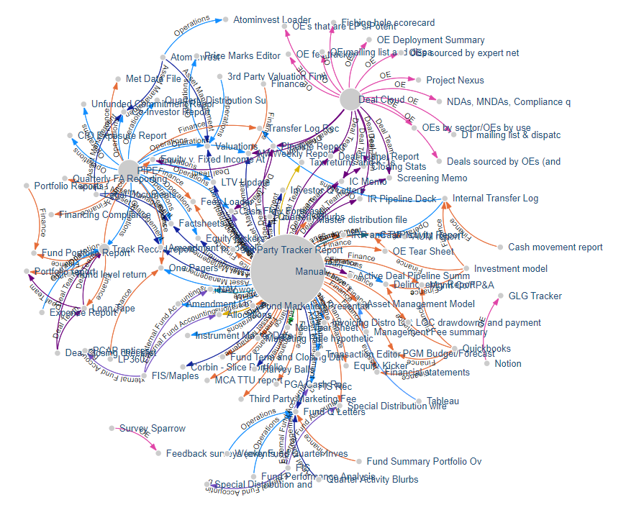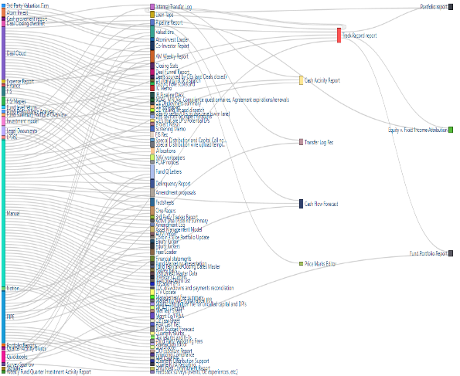
Network graphs -Report/Deliverable with Data Sources and Data Source Owner
Metropolitan’s reporting framework relies on multiple data sources and interdepartmental collaboration to produce key deliverables. While this structure enables a comprehensive and detailed approach to financial and operational reporting, it also creates challenges related to inefficiencies, delays, and a reliance on cross-functional coordination. The complexity of data dependencies introduces bottlenecks, particularly when inputs are not formally documented or centrally stored, making it difficult to track and validate information. This section outlines key reporting dependencies, the challenges they introduce, and potential areas for improvement.

Reporting Workflow and Data Dependencies
Metropolitan’s reporting process is heavily dependent on data and contributions from various teams, including Deal Teams, Asset Management, Fund Accounting, Financial Planning and Analysis (FP&A), Investor Relations, and Operations. The primary challenges in this workflow include:
- Cross-Functional Dependencies – Many reports require input from multiple teams, resulting in delays when availability and reporting timelines are misaligned.
- Manual Data Handling – A significant portion of data originates from manual inputs, increasing the risk of errors, inefficiencies, and misaligned information across teams.
- Lack of Centralized Documentation – Several reports require insights from Asset Managers and Deal Team members that are not formally recorded, making tracking and consistency difficult.
- Limited Transparency on Data Sources – Many report owners have minimal visibility into the origins and quality of the data they rely on, making issue resolution complex and increasing validation efforts.
A substantial portion of the data flows within Metropolitan are manually managed or depend on previously generated reports, further compounding the complexity. This lack of a streamlined and automated reporting system leads to inefficiencies, delays, and a higher likelihood of data inconsistencies.

Key Reports and Their Dependencies

Fund Quarterly Letter

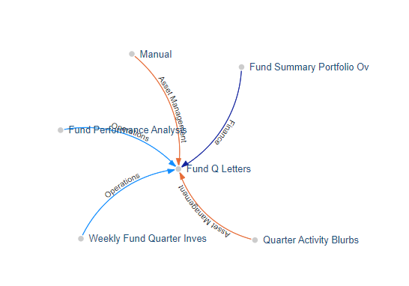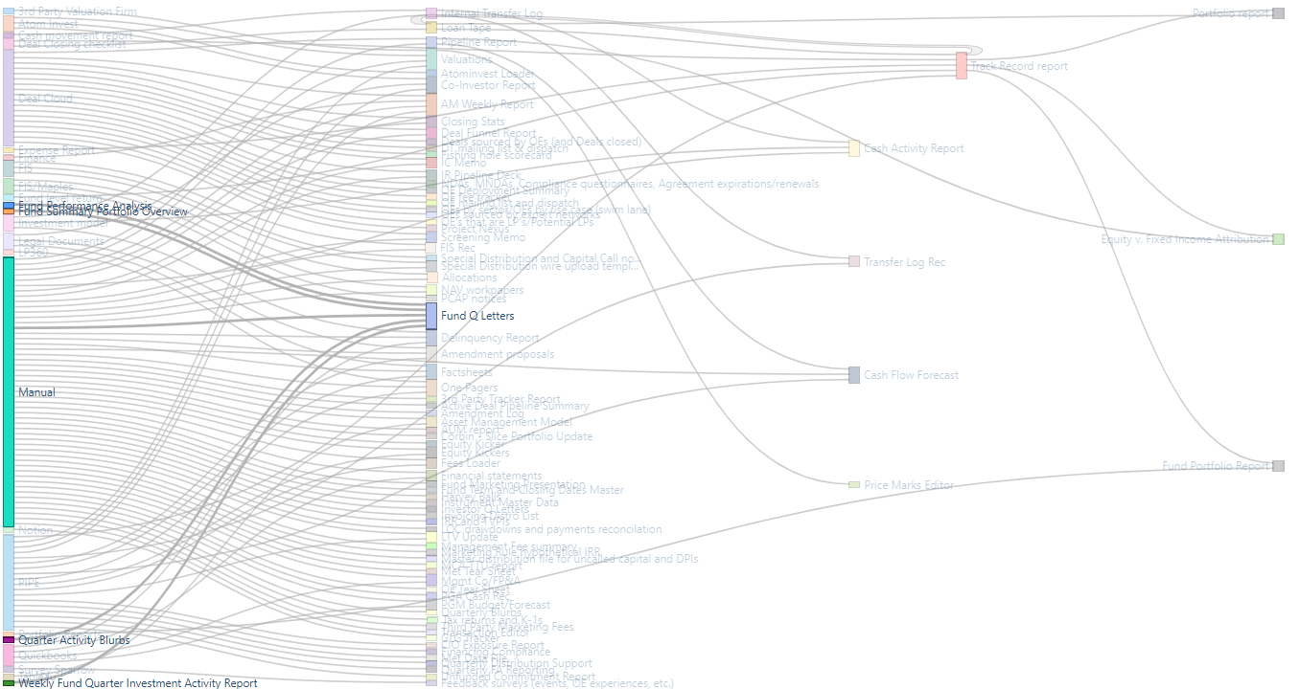
Network graphs -Report/Deliverable with Data Sources and Data Source Owner
The Fund Quarterly Letter is a critical investor-facing document that requires integration across multiple teams and internal reports.
- Contributors:
  - FP&A – Provides financial performance metrics and forward-looking projections.
  - Fund Accounting – Supplies financial statements and net asset value (NAV) calculations.
  - Asset Management – Delivers investment performance updates and valuation insights.
  - Investor Relations – Integrates the financial and operational narrative for investors and finalizes the report.
- Challenges:
  - The report requires inputs from multiple internal deliverables, making alignment complex.
  - Reliance on manual data handling increases inefficiencies and the risk of inconsistencies.
  - Dependencies on undocumented insights make it difficult to ensure data accuracy and completeness.

Co-Investor Report

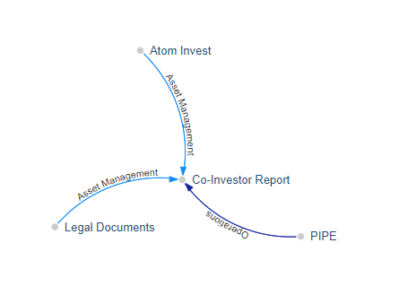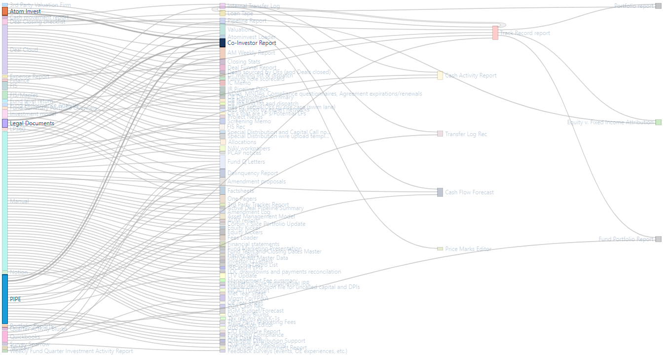
Network graphs -Report/Deliverable with Data Sources and Data Source Owner
The Co-Investor Report serves as an essential update on co-investment performance, requiring integration from multiple sources.
- Contributors:
  - Operations Team – Supplies execution updates and investment structuring details.
  - Asset Management – Provides real-time performance data and portfolio risk assessment.
  - Investor Relations – Prepares the final report and ensures consistency with broader investor communications.
- Challenges:
  - The preparation process lacks structured workflows, leading to an ad hoc approach to data collection.
  - Uncoordinated reporting cycles across teams result in inefficiencies and inconsistencies.
  - Reliance on scattered documentation makes it difficult to track and validate data sources.
The interconnected nature of these reports highlights the need for improved documentation and automation to enhance efficiency and accuracy.

